**Advanced Absorption Chiller**

**Macro – M410 – *TESTING***

Authors : SEENSO date : 21.12.2020

Technical References

|  |  |
| --- | --- |
| Project Acronym | WEDISTRICT |
| Project Title | *Smart and local reneWable Energy DISTRICT heating and cooling solutions for sustainable living* |
| Project Coordinator | ACCIONA |
| Project Duration | October - 19 / March – 23 (42 months) |

|  |  |
| --- | --- |
| Deliverable No. |  |
| Dissemination level 1 | CO |
| Work Package | WP |
| Task |  |
| Lead beneficiary |  |
| Contributing beneficiary(ies) | All |
| Due date of deliverable | 05th October 2020 |
| Actual submission date |  |

1 PU = Public

PP = Restricted to other programme participants (including the Commission Services)

RE = Restricted to a group specified by the consortium (including the Commission Services)

CO = Confidential, only for members of the consortium (including the Commission Services)

|  |
| --- |
| Document history |

|  |  |  |  |
| --- | --- | --- | --- |
| V | Date | Author/Editor | Comments |
| V0.1 | 22/02/2021 | Ignasi Gurruchaga / SEENSO |  |
| V0.2 |  |  |  |
| V0.3 |  |  |  |
| V0.4 |  |  |  |
| V1 |  |  |  |

# Executive Summary

The purpose of this document is to show the details of the Macro M410, which represents a cooling system composed of a single effect Advanced Absorption Chiller and hydraulic subsystems. This document presents a detailed description of the Macro, as well as the identification of its parameters, inputs, outputs and external files.

.

# Disclaimer

Any dissemination of results must indicate that it reflects only the author's view and that the Agency and the European Commission are not responsible for any use that may be made of the information it contains.

# Abbreviations

|  |  |
| --- | --- |
| Abbreviation | Description |
|  |  |
|  |  |
|  |  |
|  |  |
|  |  |
|  |  |
|  |  |

# Acronyms

|  |  |
| --- | --- |
| Acronym | Description |
| AAC | Advanced Absorption Chiller |

# Table of Contents

Executive Summary 4

Disclaimer 4

Abbreviations 5

Acronyms 5

Table of Contents 6

1 Introduction 7

1.1 Main purpose of the document 7

1.2 Nomenclature used in the document 7

1.3 Macros’ Programming Structure 7

1.4 Main Components 8

1.4.1 Components Description 9

1.5 Parameters, Inputs, Outputs, Results and External Files 11

1.5.1 Parameters 11

1.5.2 Inputs 16

1.5.3 Outputs 16

1.5.4 Results 16

1.5.5 External Files 17

2 Detailed Description 17

2.1 General Description. Scope, Energy and hierarchy 17

2.2 Control scheme 19

2.3 Energy and mass balance 20

3 Validation Case 20

3.1 Case 20

3.2 Results 21

# Introduction

## Main purpose of the document

To present a detailed description of the programming methodology of the M410 macro, a macro that has the purpose of representing a chilled water production system using an advanced absorption chiller operating on a packed-bed basis.

## Nomenclature used in the document

The nomenclature used in the programming of M410 macro has been based on nomenclature set in the present project. Based on this, the nomenclature applied to the identification of macro associated with the refrigeration system is M410X (where X is the index of macro within deck). On the other hand, the nomenclature applied to components within the macro is M410X_COMPO, where COMPO is the component’s name (for example, ACH01, PI01, HX01, etc). Finally, the code applied to variables within the macro is M410X_COMPO_JJJJ, where in JJJJ, which is necessary to specify the characteristic parameter or variable name, and its respective address (In or Out) or additional information.

## Macros’ Programming Structure

A macro is a grouping of TRNSYS components that perform a certain task within a deck. This task consists of the representation of a part of a system (a collector subsystem, an accumulation subsystem, a heat or cold production subsystem). In this case, the macro M410 represents a cooling system that is composed of an Advanced Absorption Chiller (AAC), which is connected to three hydraulic circuits. The first one corresponds to the chilled water loop, the second one corresponds to the hot water loop and the third one corresponds to the cooling water loop.

A simplified schematic of the M410 macro is shown in the following illustration, in which the components that make up the chilled water production system can be seen. These components correspond to an Advanced Absorption Chiller, a chilled water storage tank, a cooling tower, a control system, pumps, and piping. Also, two data inputs and two data outputs can be observed. Regarding the incoming data, these come from external macros and contribute to the correct operation of the macro. On the other hand, the results obtained are output data from the M410 macro that are directed to the external macros.

The data entered in the first input corresponds to meteorological data and data of mass flow and temperature of the hot fluid that feeds the Chiller Generator. Regarding the data provided by the first output, these correspond mainly to hourly data of mass flow and temperature of the cooled hot water coming from the Generator. On the other hand, the data that enters the second input corresponds to hourly demand data, and the second output corresponds to the hourly results of mass flow and chilled water temperature that are directed to the Demand Macro.

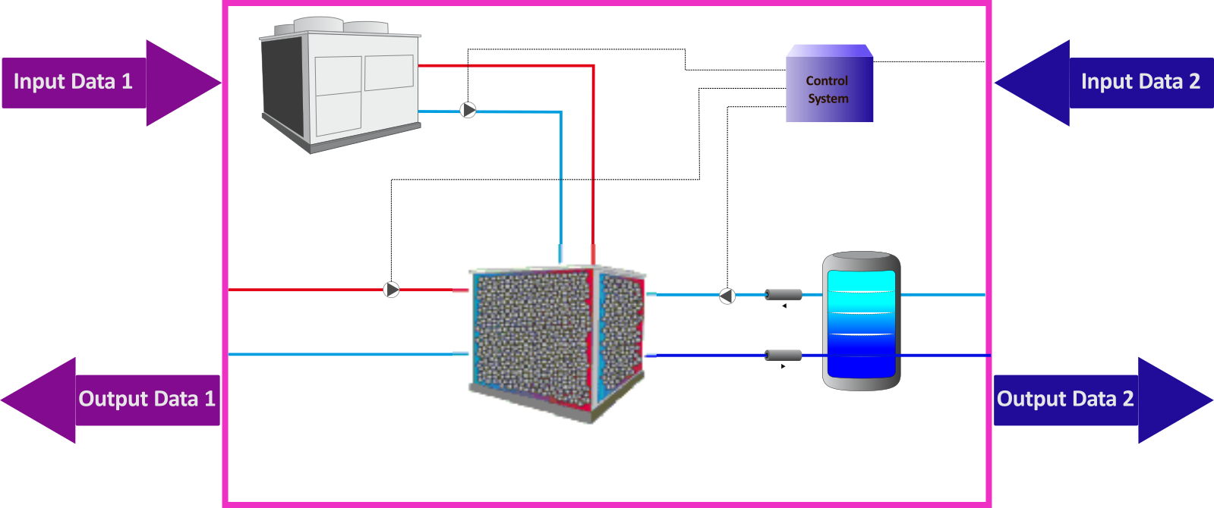

Figure 1 – Schematic of Conventional Absorption System

The nominal operating conditions that were programmed into the M410 macro are as follows:

* Cooling power: 100 kW
* COP: 0.8599
* Chilled water set point temperature: 7°C
* Chilled water thermal gap: 5°C
* Hot water inlet temperature: 95°C
* Hot water outlet temperature: 90°C
* Cooling water inlet temperature: 31.5°C
* Cooling water outlet temperature: 36.5°C

The chilled water production system comes into operation when three essential conditions are met: there is a demand for cooling, the temperature of the hot flow that feeds the chiller has a temperature within the optimum range, and the high temperature of the accumulator is greater than 13°C (64°F).

## Main Components

Below, there is a list of main types that are part of M410. Also, DLLs associated with those types are shown.

|  |  |  |  |
| --- | --- | --- | --- |
| Component | Type | Standard | DLL |
| Absorption Chiller | Type 202 | No | Type202_x64.dll |
| Cooling Storage Tank | Type 534 | Yes | TRNDll.dll |
| Cooling Tower | Type 128 | Yes | TRNDll.dll |
| Pipes | Type 709 | Yes | TRNDll.dll |
| Pump | Type 110 | Yes | TRNDll.dll |
| Online Plotter | Type 65 | Yes | TRNDll.dll |
| Control | Type 2 | Yes | TRNDll.dll |

### Components Description

The following is a brief description of the main components that comprise M410 macro.

#### Type 202 (M4100_AAC)

This type represents an Advanced Absorption Chiller, a system that consists mainly of an evaporator, and absorber, a generator, and two packed beds that act as condenser and preheater in different stages of process. The main peculiarity of this absorption chiller is the inclusion of those packed bed material acting as condensers and preheaters. In this way, most of the energy of the condensation process that in conventional absorption chillers would be wasted, is used to preheat the diluted solution before it arrives at the generator. This fact increases the cycle COP and reduces the cooling tower size. Moreover, the inclusion of packed bed material in these two components allows the systems to get a temperature stratification, which enhances the operational conditions of the cycle.

The use of cycling packed beds in the absorption cycle means that the equipment is constantly operating in transient mode, as the temperatures of the beds and the preheated solution change over time. However, this transient operation is cyclic, since the operating conditions are repeated each time, the beds change from condenser mode to heat recovery mode. The time each cycle lasts essentially depends on the partial load at which the system is operating, the mathematical expression of which is shown below:

|  |  |
| --- | --- |
|  | Equation 1 |

Where , and .

The behavior of the cycle time as a function of partial load is presented as follows:

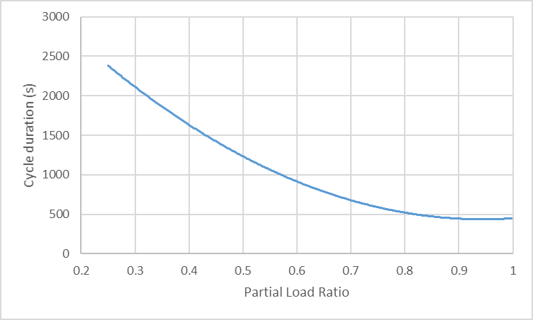

Figure 3. Duration of each cycle as a function of partial load

The change in the performance of the absorption machine over the cycle can be assumed linear. Thus:

1. The cold produced by the absorption machine decreases by 1.5% for every 200s of operation.
2. The heat required in the generator increases by 2.0% for every 200 s of operation.
3. The heat dissipated in the absorber increases by 0.5% per 200s of operation.

Within the Source Code, the percentage of the cycle evolution and the elapsed time within the cycle are presented below:

|  |  |
| --- | --- |
|  | Equation 2 |
|  | Equation 3 |

With this last value, the decay of the operating conditions due to the nature of the chiller is estimated.

In addition, to operate, this type uses a single data file to predict the performance of a single effect, hot water fired absorption chiller. The file must contain values of normalized fraction of full load capacity and fraction of design energy input for various values of fraction of design load (-), chilled water setpoint temperature (°C), entering cooling water temperature (°C) and entering hot water temperature (°C).

#### Type 128 (M4100_CT0X)

Type 128 estimates the performance of a cooling tower without any detailed parameters of the tower configuration. Instead, it uses the design inlet and outlet conditions to calculate an overall heat transfer coefficient (UA) for the tower and then uses that UA value to estimate performance at other inlet conditions. This version calculates the performance of a two speed cooling tower that provides cooling to the fluid stream with the fan at high speed, at low speed, and off (natural convection). The control for this version is a fan and fluid control signal where the model calculates the outlet conditions that would be achieved with the inlet conditions and control signals.

#### Type 534 (M4100_ST0X)

This type models a fluid-filled and constant volume storage with a cylindrical and vertical configuration. The fluid in the storage tank interacts with the environment (through thermal losses from the top, bottom, and edges) and with up to two flow streams that pass into and out of the storage tank. The tank is divided into isothermal temperature nodes (to model stratification observed in storage tanks) where the user controls the degree of stratification through the specification of the number of “nodes”. Each constant-volume node is assumed to be isothermal and interacts thermally with the nodes above and below through several mechanisms; fluid conduction between nodes, and through fluid movement. The model also considers temperature-dependent fluid properties for either pure water, ethylene glycol and water solution, or propylene glycol and water solution for both the tank and heat exchanger fluids.

#### Type 709 (M4100_PI0X)

This type models the thermal behavior of a fluid passing through a pipe using variable size segments in case of longitudinal temperature discretization. This component is analogous to type 31; however, instead of asking the user to provide an overall UA value for the pipe and its insulation, the user is asked here to provide the physical characteristics of the pipe material, the fluid, and the insulation material.

#### Type 110 (M4100_PU0X)

Type 110 represents a variable speed pump that can maintain any outlet mass flow rate between zero and a nominal value. Among the necessary parameters to be specified in this type are the nominal mass flow rate, the fluid specific heat, the consumption associated with the operation, the motor heat loss fraction, among others. Regarding the input variables, these are the temperature and mass flow of the fluid entering the pump, a control signal, the pump overall efficiency and the motor efficiency.

In M420 no heat transfer from the pump to the fluid is considered.

#### Type 2d (M4100_CON0X)

This type represents a controller that generates a control function that can take a value equal to 0 or 1. This value is chosen according to the difference between the upper and lower temperatures (TH and TL) compared to two deadband temperature differences (Δ𝑇𝐻 and Δ𝑇𝐿). The new value of depends on whether the input control signal is on or off (=0 or 1). The controller is normally used with the output control signal () connected to the inlet control signal (γ_i) giving a hysteresis effect. A high limit cut-out is included with the Type 2 controller. Regardless of the deadband conditions, the control function will be set to zero if the high limit condition is exceeded.

## Parameters, Inputs, Outputs, Results and External Files

Below are Parameters, Inputs, Outputs, Results and External Files considered in M420 macro:

### Parameters

| Name | Units | Description | Component |
| --- | --- | --- | --- |
| M4100_AAC01_Cp_CHW | kJ/kg.K | Fluid specific heat (chilled water loop) | M4100_AAC01 M4100_PI01 M4100_PI02 M4100_PU01 M4100_PU02 M4100_PU03 |
| M4100_AAC01_Cp_HW | kJ/kg.K | Fluid specific heat (hot water loop) | M4100_AAC01 M4100_PI01 M4100_PI02 M4100_PU01 M4100_PU02 M4100_PU03 |
| M4100_AAC01_Cp_COW | kJ/kg.K | Fluid specific heat (cooling water loop) | M4100_AAC01 M4100_PI01 M4100_PI02 M4100_PU01 M4100_PU02 M4100_PU03 |
| M4100_AAC01_Ro_CHW | kg/m3 | Fluid density (chilled water loop) | M4100_PI01 M4100_PI02 |
| M4100_AAC01_Ro_HW | kg/m3 | Fluid density (hot water loop) | M4100_PI01 M4100_PI02 |
| M4100_AAC01_Ro_COW | kg/m3 | Fluid density (cooling water loop) | M4100_PI01 M4100_PI02 |
| M4100_AAC01_Mu_CHW | kg/m.h | Fluid viscosity (chilled water loop) | M4100_PI01 M4100_PI02 |
| M4100_AAC01_Mu_HW | kg/m.h | Fluid viscosity (hot water loop) | M4100_PI01 M4100_PI02 |
| M4100_AAC01_Mu_COW | kg/m.h | Fluid viscosity (cooling water loop) | M4100_PI01 M4100_PI02 |
| M4100_AAC01_K_CHW | kJ/h.m.K | Fluid thermal conductivity (chilled water loop) | M4100_PI01 M4100_PI02 |
| M4100_AAC01_K_HW | kJ/h.m.K | Fluid thermal conductivity (hot water loop) | M4100_PI01 M4100_PI02 |
| M4100_AAC01_K_COW | kJ/h.m.K | Fluid thermal conductivity (cooling water loop) | M4100_PI01 M4100_PI02 |
| M4100_AAC01_QCHWNom | kJ/hr | Nominal Capacity | M4100_AAC01 |
| M4100_AAC01_COPNom | - | Nominal COP | M4100_AAC01 |
| M4100_AAC01_TCHWInNom | °C | Chilled water inlet temperature | M4100_AAC01 |
| M4100_AAC01_TCHWOuNom | °C | Chilled water outlet temperature | M4100_AAC01 |
| M4100_AAC01_THWInNom | °C | Hot water inlet temperature | M4100_AAC01 |
| M4100_AAC01_THWOuNom | °C | Hot water outlet temperature | M4100_AAC01 |
| M4100_AAC01_TCOWInNom | °C | Cooling water inlet temperature | M4100_AAC01 |
| M4100_AAC01_TCOWOuNom | °C | Cooling water outlet temperature | M4100_AAC01 |
| M4100_AAC01_coefa | - | Second order coefficient associated with the cycle time equation. | M4100_AAC01 |
| M4100_AAC01_coefb | - | First order coefficient associated with the cycle time equation. | M4100_AAC01 |
| M4100_AAC01_coefc | - | Free coefficient associated with the cycle time equation. | M4100_AAC01 |
| M4100_AAC01_fcycleperiod | seconds | Reference period. | M4100_AAC01 |
| M4100_AAC01_fQCHW | - | Percentage decrease in cold generated due to cyclic behavior. | M4100_AAC01 |
| M4100_AAC01_fQCOW | - | Percentage of additional heat to be dissipated in the absorber due to cyclic behavior. | M4100_AAC01 |
| M4100_AAC01_fQHW | - | Percentage of additional heat required in the generator due to system cyclic behavior. | M4100_AAC01 |
| M4100_AAC01_LU | - | Logical unit for the performance data file | M4100_AAC01 |
| M4100_AAC01_ExtFil_HW | - | Number of HW temperatures in data file | M4100_AAC01 |
| M4100_AAC01_ExtFil_COW | - | Number of CW steps in data file | M4100_AAC01 |
| M4100_AAC01_ExtFil_CHW | - | Number of CHW setpoints in data file | M4100_AAC01 |
| M4100_AAC01_ExtFil_PLR | - | Number of load fractions in data file | M4100_AAC01 |
| M4100_AAC01_Wpower | kJ/h | Auxiliary electrical power | M4100_AAC01 |
| M4100_AAC01_TCHWset | °C | CHW setpoint | M4100_AAC01 |
| M4100_AAC01_QHWNom | kJ/hr | Hot water energy | M4100_AAC01 |
| M4100_AAC01_QCOWNom | kJ/hr | Cooling water energy | M4100_AAC01 |
| M4100_AAC01_MCHWNom | kg/h | Chilled water flow rate | M4100_AAC01 |
| M4100_AAC01_MHWNom | kg/h | Hot water flow rate | M4100_AAC01 |
| M4100_AAC01_MCOWNom | kg/h | Cooling water flow rate | M4100_AAC01 |
| M4100_CT01_AtmPressNom | atm | Atmospheric pressure at design | M4100_CT01 |
| M4100_CT01_MairNom | kg/hr | Air flow rate at design | M4100_CT01 |
| M4100_CT01_AirWTNom | °C | Entering wetbulb temperature at design | M4100_CT01 |
| M4100_CT01_FanWNom | kJ/hr | Fan power at design | M4100_CT01 |
| M4100_CT01_LSAirFrac | Fraction | Low speed airflow fraction | M4100_CT01 |
| M4100_LSCapFrac | Fraction | Low speed capacity fraction | M4100_CT01 |
| M4100_CT01_ConvAirFrac | Fraction | Natural convection airflow fraction | M4100_CT01 |
| M4100_CT01_ConvCapFrac | Fraction | Natural convection capacity fraction | M4100_CT01 |
| M4100_ST01_Loc | - | Storage tank location | M4100_ST01 |
| M4100_ST01_Vol | m3 | Tank volume | M4100_ST01 |
| M4100_ST01_Height | m | Tank height | M4100_ST01 |
| M4100_ST01_Fluidcp | kJ/kg.K | Fluid specific heat | M4100_ST01 |
| M4100_ST01_Fluidrho | kg/m3 | Fluid density | M4100_ST01 |
| M4100_ST01_Fluidmu | kg/m.hr | Fluid viscosity | M4100_ST01 |
| M4100_ST01_Fluidk | kJ/hr.m.K | Fluid thermal conductivity | M4100_ST01 |
| M4100_ST01_IsoTopTh | m | Top insulation thickness | M4100_ST01 |
| M4100_ST01_IsoTopK | W.m.K | Top thermal conductivity | M4100_ST01 |
| M4100_ST01_IsoLatTh | m | Edge insulation thickness | M4100_ST01 |
| M4100_ST01_IsoLatK | W.m.K | Edge thermal conductivity | M4100_ST01 |
| M4100_ST01_IsoBotTh | m | Bottom insulation thickness | M4100_ST01 |
| M4100_ST01_IsoBotK | W.m.K | Bottom thermal conductivity | M4100_ST01 |
| M4100_ST01_Utop | kJ/hr.m2.K | Top loss coefficient | M4100_ST01 |
| M4100_ST01_Ulat | kJ/hr.m2.K | Edge Loss Coefficient | M4100_ST01 |
| M4100_ST01_Ubot | kJ/hr.m2.K | Bottom Loss Coefficient | M4100_ST01 |
| M4100_ST01_P1Mode | - | Inlet Flow Mode-1 | M4100_ST01 |
| M4100_ST01_P1In | - | Entry Node-1 | M4100_ST01 |
| M4100_ST01_P1Ou | - | Exit Node-1 | M4100_ST01 |
| M4100_ST01_P2Mode | - | Inlet Flow Mode-2 | M4100_ST01 |
| M4100_ST01_P2In | - | Entry Node-2 | M4100_ST01 |
| M4100_ST01_P2Ou | - | Exit Node-2 | M4100_ST01 |
| M4100_ST01_P3Mode | - | Inlet Flow Mode-3 | M4100_ST01 |
| M4100_ST01_P3In | - | Entry Node-3 | M4100_ST01 |
| M4100_ST01_P3Ou | - | Exit Node-3 | M4100_ST01 |
| M4100_ST01_Tt0 | °C | Initial Tank Temperature | M4100_ST01 |
| M4100_PU01_M | kg/h | Nominal pump mass flow rate | M4100_PU01 |
| M4100_PU01_V | m3/h | Pump flow rate | M4100_PU01 |
| M4100_PU01_AP | Pa | Nominal pressure difference | M4100_PU01 |
| M4100_PU01_P | kJ/h | Rated power consumption | M4100_PU01 |
| M4100_PU02_M | kg/h | Rated flow rate | M4100_PU02 |
| M4100_PU02_V | m3/h | Pump flow rate | M4100_PU02 |
| M4100_PU02_AP | Pa | Nominal pressure difference | M4100_PU02 |
| M4100_PU02_P | kJ/h | Rated power consumption | M4100_PU02 |
| M4100_PU03_M | kg/h | Rated flow rate | M4100_PU03 |
| M4100_PU03_V | m3/h | Pump flow rate | M4100_PU03 |
| M4100_PU03_AP | Pa | Nominal pressure difference | M4100_PU03 |
| M4100_PU03_P | kJ/h | Rated power consumption | M4100_PU03 |
| M4100_PI0102_Loc | - | Pipe location: 0=External 1=Internal 2=Buried | M4100_PI01 M4100_PI02 |
| M4100_PI01_Di | m | Inside diameter | M4100_PI01 M4100_PI02 |
| M4100_PI01_e | m | Pipe thickness. Based on tabulated data, a linear correlation is obtained by using the polyfit function in the python program. For more information, see annexes. | M4100_PI01 M4100_PI02 |
| M4100_PI01_Do | m | Outside diameter | M4100_PI01 M4100_PI02 |
| M4100_PI01_Kpi | kJ/h.m.K | Pipe thermal conductivity | M4100_PI01 M4100_PI02 |
| M4100_PI01_Insth | m | Insulation thickness. Based on tabulated data, a linear correlation is obtained by using the polyfit function in the python program. For more information, see annexes. | M4100_PI01 M4100_PI02 |
| M4100_PI01_Insk | kJ/h.m.K | Conductivity of insulation | M4100_PI01 M4100_PI02 |
| M4100_PI01_L | m | Pipe length. | M4100_PI01 M4100_PI02 |
| M4100_PI01_L2 | m | Total pipe length. Forward and Return. | M4100_PI01 M4100_PI02 |
| M0100_LU_MET | - | Shut off Online w/o removing | - |
| Type_Meteofile | TMY2 | The type of file which is to be read: 1 = TMY format, 2 = TMY2 format, 3 = Energy+ format, 4 = IWEC format, 5 = CWEC format, 6=Metoenorm for TRNSYS format, 7 = TMY3 format, 8 = German TRY 2004 format, 8 = German TRY 2010 format | - |
| Mode_TiltSurf | TMY2 | The radiation processing mode that will be used to calculate the radiation components on a tilted surface: 1= Isotropic Sky Model, 2 = Hay and Davies Model, 3 = Reindl Model, 4 = Perez 1988 Model. 5 = Perez 1999 Model. Refer to the documentation for the Type 16 model for more information. | - |
| PAR_LOC | - | Location | - |
| Gth | kWh/m2 | The total radiation (beam + diffuse) incident upon a horizontal surface. ### Only used for pre-sizing WESSUN collector area ###. | - |
| Gbh | kWh/m2 | The beam radiation incident upon a horizontal surface. ### Only used for pre-sizing WESSUN collector area ###. | - |
| Gdh | kWh/m2 | The diffuse radiation incident upon a horizontal surface. ### Only used for pre-sizing WESSUN collector area ###. | - |
| Itmax | kJ/h.m2 | Maximum global solar radiation on a normal-to-sun surface. Used in sizing solar power. | - |
| Itnom | W/m2 | The mean (average) global radiation during sunny days throughout the year. ### Only used for pre-sizing WESSUN collector area ###. | - |
| Lat | ° | Location latitude | - |
| TAirAve | °C | The mean (average) temperature during the year. Used in ground temperature estimation and for ### pre-sizing WESSUN collector area ###. | - |
| ATAir | °C | The amplitude of the anual temperature throughout the year. Used in ground temperature estimation. | - |
| TAirTime | - | Time shift (in days) between the beginning of the calendar year and the occurence of the minimum surface temperature. Used in ground temperature estimation. Correlation relates to south or north hemisphere. | - |
| GrRef | - | Ground reflectance | - |
| ONLINE | - | Shut off Online w/o removing | - |
| WTOKJPH | W to kJ/h | Conversion from W to kJ/h | - |
| PI | - | PI Value | - |
| eta_pump | - | Hydraulic efficiency | - |
| CpAgua | kJ/kg.K | Fluid specific heat (water) | - |
| RoAgua | kg/m3 | Fluid density (water) | - |
| MuAgua | kg/m.h | Fluid viscosity (water) | - |
| Kagua | kJ/h.m.K | Fluid thermal conductivity (water) | - |
| ExtSurConvCoef | kJ/h.m2.K | Outdoor convection coefficient | - |
| SoilCond | kJ/h.m.K | Soil thermal conductivity | - |
| SoilDensity | kg/m3 | Soil density | - |
| SoilCp | kJ/kg.K | Soil specific heat | - |
| RoAir | kg/m3 | Air density | - |

### Inputs

| Name | Units | Description | Component |
| --- | --- | --- | --- |
| M4100_TIn1 | °C | Chilled water inlet temperature | In1 |
| M4100_MIn1 | Kg/hr | Chilled water flow rate | In1 |
| M4100_TIn2 | °C | Hot water inlet temperature | In2 |
| M4100_MIn2 | Kg/hr | Hot water flow rate | In2 |
| M0100_Tamb | °C | Dry bulb temperature | In1 |
| M0100_Tgr1 | °C | Soil temperature at 1 atm | In1 |
| M0100_TaT20mean | °C | Mean temperature between climated room and Tamb | In1 |
| M0100_Pamb | atm | Atmospheric pressure | In1 |
| M0100_TambW | °C | Wet bulb temperature | In1 |

### Outputs

|  |  |  |  |
| --- | --- | --- | --- |
| Name | Unit | Description | Component |
| M4100_TOu2 | °C | Chilled water temperature | Ou2 |
| M4100_MOu2 | Kg/hr | Chilled water flow rate | Ou2 |
| M4100_TOu1 | °C | Hot water outlet temperature | Ou1 |
| M4100_MOu1 | Kg/hr | Hot water flow rate | Ou1 |

### Results

| Name | Unit | Description | Component |
| --- | --- | --- | --- |
| M4100_RES_QCHW | kWh | Chiller water energy | M4100_AAC01 |
| M4100_RES_QHW | kWh | Hot water energy | M4100_AAC01 |
| M4100_RES_QCOW | kWh | Cooling water energy | M4100_AAC01 |
| M4100_RES_Qin | kWh | Input energy | M4100_AAC01 |
| M4100_RES_Qou | kWh | Output energy | M4100_AAC01 |
| M4100_RES_AAC01_TIn1 | °C | Chilled water inlet temperature | M4100_AAC01 |
| M4100_RES_AAC01_TOu1 | °C | Chilled water outlet temperature | M4100_AAC01 |
| M4100_RES_AAC01_TIn2 | °C | Hot water inlet temperature | M4100_AAC01 |
| M4100_RES_AAC01_TOu2 | °C | Hot water outlet temperature | M4100_AAC01 |
| M4100_RES_AAC01_TIn3 | °C | Cooling water inlet temperature | M4100_AAC01 |
| M4100_RES_AAC01_TOu3 | °C | Cooling water outlet temperature | M4100_AAC01 |
| M4100_RES_AAC01_MIn1 | Kg/h | Chilled water flow rate (input) | M4100_AAC01 |
| M4100_RES_AAC01_MOu1 | Kg/h | Chilled water flow rate (output) | M4100_AAC01 |
| M4100_RES_AAC01_MIn2 | Kg/h | Hot water flow rate (input) | M4100_AAC01 |
| M4100_RES_AAC01_MOu2 | Kg/h | Hot water flow rate (output) | M4100_AAC01 |
| M4100_RES_AAC01_MIn3 | Kg/h | Cooling water flow rate (input) | M4100_AAC01 |
| M4100_RES_AAC01_MOu3 | Kg/h | Cooling water flow rate (output) | M4100_AAC01 |
| M4100_RES_PU01_WPr | MWh | Power consumed by P01 | M4100_PU01 |
| M4100_RES_PU02_WPr | kWh | Power consumed by P02 | M4100_PU02 |
| M4100_RES_PU03_WPr | kWh | Power consumed by P03 | M4100_PU03 |
| M4100_RES_CT01_WPr | kWh | Power consumed by CT01 | M4100_CT01 |
| M4100_RES_W | kWh | Total power consumption | - |
| M4100_RES_PI01_QLs | kWh | Environmental losses in PI01 | M4100_PI01 |
| M4100_RES_PI02_QLs | kWh | Environmental losses in PI02 | M4100_PI02 |
| M4100_RES_PI12_QLs | kWh | Environmental losses in PI1 and PI02 | - |
| M4100_RES_PI01_dQ | kWh | Change in internal energy in PI01 | M4100_PI01 |
| M4100_RES_PI02_dQ | kWh | Change in internal energy in PI02 | M4100_PI02 |
| M4100_RES_ST01_QLsT | kWh | Top losses in storage tank | M4100_ST01 |
| M4100_RES_ST01_QLsE | kWh | Edge losses in storage tank | M4100_ST01 |
| M4100_RES_ST01_QLsB | kWh | Bottom losses in storage tank | M4100_ST01 |
| M4100_RES_ST01_QLs | kWh | Total losses in storage tank | M4100_ST01 |
| M4100_RES_ST01_dQ | kWh | Tank energy storage rate | M4100_ST01 |
| M4100_RES_CON04_Ou | - | Control system response | M4100_PU01  M4100_PU02  M4100_PU03  M4100_CT01 |
| M4100_RES_TIn2 | °C | Inlet temperature for port-1 | M4100_ST01 |
| M4100_RES_TOu2 | °C | Temperature at outlet-1 | M4100_ST01 |
| M4100_RES_COP | - | COP | M4100_AAC01 |
| M4100_RES_EB | MWh | Energy balance | - |
| M4100_RES_ST01_P1MIn | kg/h | Mass flow into Port 1 | M4100_ST01 |
| M4100_RES_ST01_P1MOu | kg/h | Mass flow leaving Port 1 | M4100_ST01 |
| M4100_RES_ST01_P2MIn | kg/h | Mass flow into Port 2 | M4100_ST01 |
| M4100_RES_ST01_P2MOu | kg/h | Mass flow leaving Port 2 | M4100_ST01 |
| M4100_RES_PI01_MIn1 | kg/h | Mass flow rate (input) | M4100_PI01 |
| M4100_RES_PI01_MOu1 | kg/h | Mass water flow rate (output) | M4100_PI01 |
| M4100_RES_PI02_MIn1 | kg/h | Mass flow rate (input) | M4100_PI02 |
| M4100_RES_PI02_MOu1 | kg/h | Mass water flow rate (output) | M4100_PI02 |
| M4100_RES_PU01_MIn1 | kg/h | Mass flow rate (input) | M4100_PU01 |
| M4100_RES_PU01_MOu1 | kg/h | Mass water flow rate (output) | M4100_PU01 |
| M4100_RES_PU02_MIn1 | kg/h | Mass flow rate (input) | M4100_PU02 |
| M4100_RES_PU02_MOu1 | kg/h | Mass water flow rate (output) | M4100_PU02 |
| M4100_RES_PU03_MIn1 | kg/h | Mass flow rate (input) | M4100_PU03 |
| M4100_RES_PU03_MOu1 | kg/h | Mass water flow rate (output) | M4100_PU03 |
| M4100_RES_CT01_MIn1 | kg/h | Mass flow rate (input) | M4100_CT01 |
| M4100_RES_CT01_MOu1 | kg/h | Mass water flow rate (output) | M4100_CT01 |
| M4100_RES_AAC01_WPr | kWh | Electrical consumption | M4100_AAC01 |
| M4100_RES_ST01_Vol | m3 | Volume of accumulation | M4100_ST01 |
| M4100_RES_CT01_TIn1 | °C | Temperature (input) | M4100_CT01 |
| M4100_RES_CT01_TOu1 | °C | Temperature (output) | M4100_CT01 |
| M4100_RES_AAC01_CE | s | Actual cycle evolution | M4100_AAC01 |
| M4100_RES_AAC01_CT | - | Actual cycletime | M4100_AAC01 |
| M4100_RES_AAC01_cPLR | - | Partial Load Ratio | M4100_AAC01 |
| M4100_RES_AAC01_fD | - | Design Fraction | M4100_AAC01 |
| M4100_RES_TIME | h | Time | - |
| M4100_RES_CE | - | Previous cycle evolution | M4100_AAC01 |
| M4100_RES_CT | s | Previous cycletime | M4100_AAC01 |
| M4100_RES_OTAAC | h | Operation Time | M4100_AAC01 |
| M4100_RES_rauxAAC | - | Auxiliary consumption Energy Ratio | M4100_AAC01 |
| M4100_RES_FEC1 | kWh | Final Energy consumption associated to source 1 | - |
| M4100_RES_FEC2 | kWh | Final Energy consumption associated to source 2 | - |
| M4100_RES_FEC3 | kWh | Final Energy consumption associated to source 3 | - |
| M4100_RES_FEC4 | kWh | Final Energy consumption associated to source 4 | - |
| M4100_RES_FEC5 | kWh | Final Energy consumption associated to source 5 | - |
| M4100_RES_FEC6 | kWh | Final Energy consumption associated to source 6 | - |
| M4100_RES_FEC7 | kWh | Final Energy consumption associated to source 7 | - |
| M4100_RES_FEC8 | kWh | Final Energy consumption associated to source 8 | - |
| M4100_RES_FEC9 | kWh | Final Energy consumption associated to source 9 | - |
| M4100_RES_FEC10 | kWh | Final Energy consumption associated to source 10 | - |
| M4100_RES_FEC11 | kWh | Final Energy consumption associated to source 11 | - |
| M4100_RES_FEC12 | kWh | Final Energy consumption associated to source 12 | - |
| M4100_RES_FEC13 | kWh | Final Energy consumption associated to source 13 | - |
| M4100_RES_FEC14 | kWh | Final Energy consumption associated to source 14 | - |
| M4100_RES_FEC15 | kWh | Final Energy consumption associated to source 15 | - |

### External Files

|  |  |
| --- | --- |
| Name | Component |
| Type202-AdvancedAbsorptionChiller.dat | M4100_AAC01 |

# Detailed Description

## General Description. Scope, Energy and hierarchy

The purpose of the M410 macro is to produce chilled water from Advanced Absorption technology. The following is the schematic of the M410 macro in the TRNSYS interface.

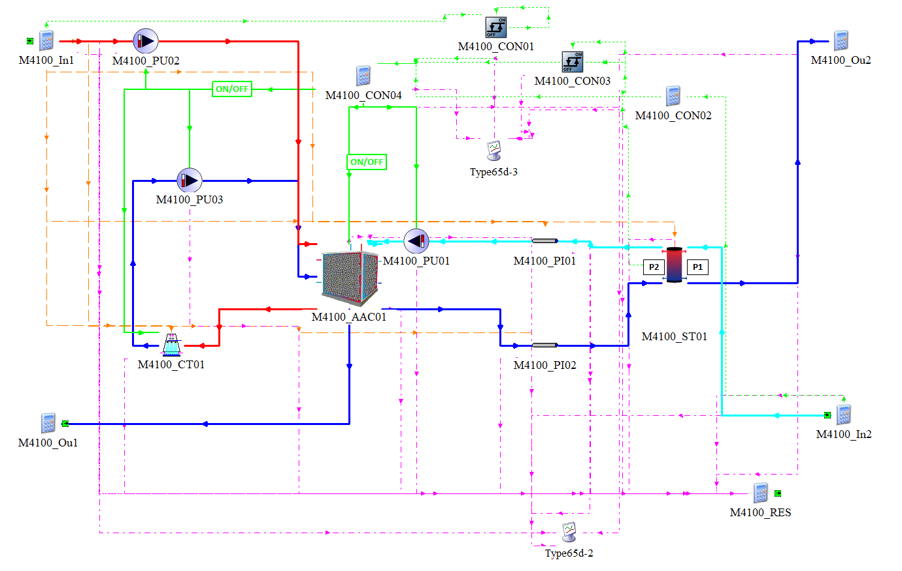

Figure 2 – Macro M420

Within the WeDistrict project, the Advanced Absorption Chiller (AAC) technology is intended to function as a base technology to produce chilled water. This Advanced Absorption Machine corresponds to a single-effect machine that works based on three hydraulic circuits. The first corresponds to the cold-water loop (L1), the second to the hot water loop (L2) and the third to the cooling water loop (L3).

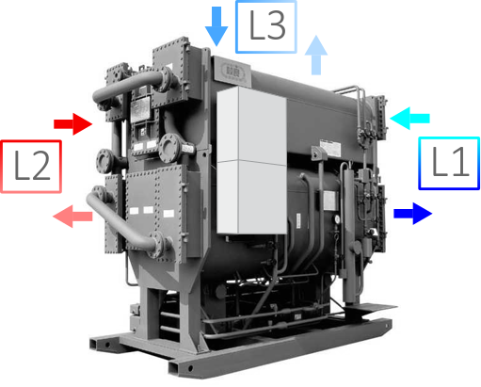

Figure 3 – Conventional Absorption Chiller

The first loop (L1), which corresponds to the chilled water loop, corresponds to a piping system (PI01-PI02), a pump (PU01) and a thermal storage system (ST01). The purpose of this circuit is to satisfy the cooling demand coming from the Demand Macro, whose hourly data correspond to an input of the macro under analysis. Within this circuit, the flow of chilled water produced in the conventional absorption chiller is pumped to the storage tank, flow that enters through the inlet of Port 2 (P2). On the other hand, the water flow associated with the demand, which is at a higher temperature, enters Port 1 inlet (P1). From the stabilization of the mixture of both fluids, the stratification phenomenon occurs, which allows differentiating the low and high temperature zones, as shown in the following illustration. As can be seen, the high temperature fluid is deposited in the upper zone of the accumulator, and the low temperature fluid is deposited in the lower zone. Because of this, the outlet of Port 1 is in the lower zone, where the cooled water is extracted to be sent to the Demand Macro. As can be seen, the hourly data corresponding to the flow of chilled water corresponds to an output of the macro under analysis. As for the Port 2 outlet, it is in the upper zone of the accumulation tank, where the higher temperature water is extracted to be sent to the absorption machine.

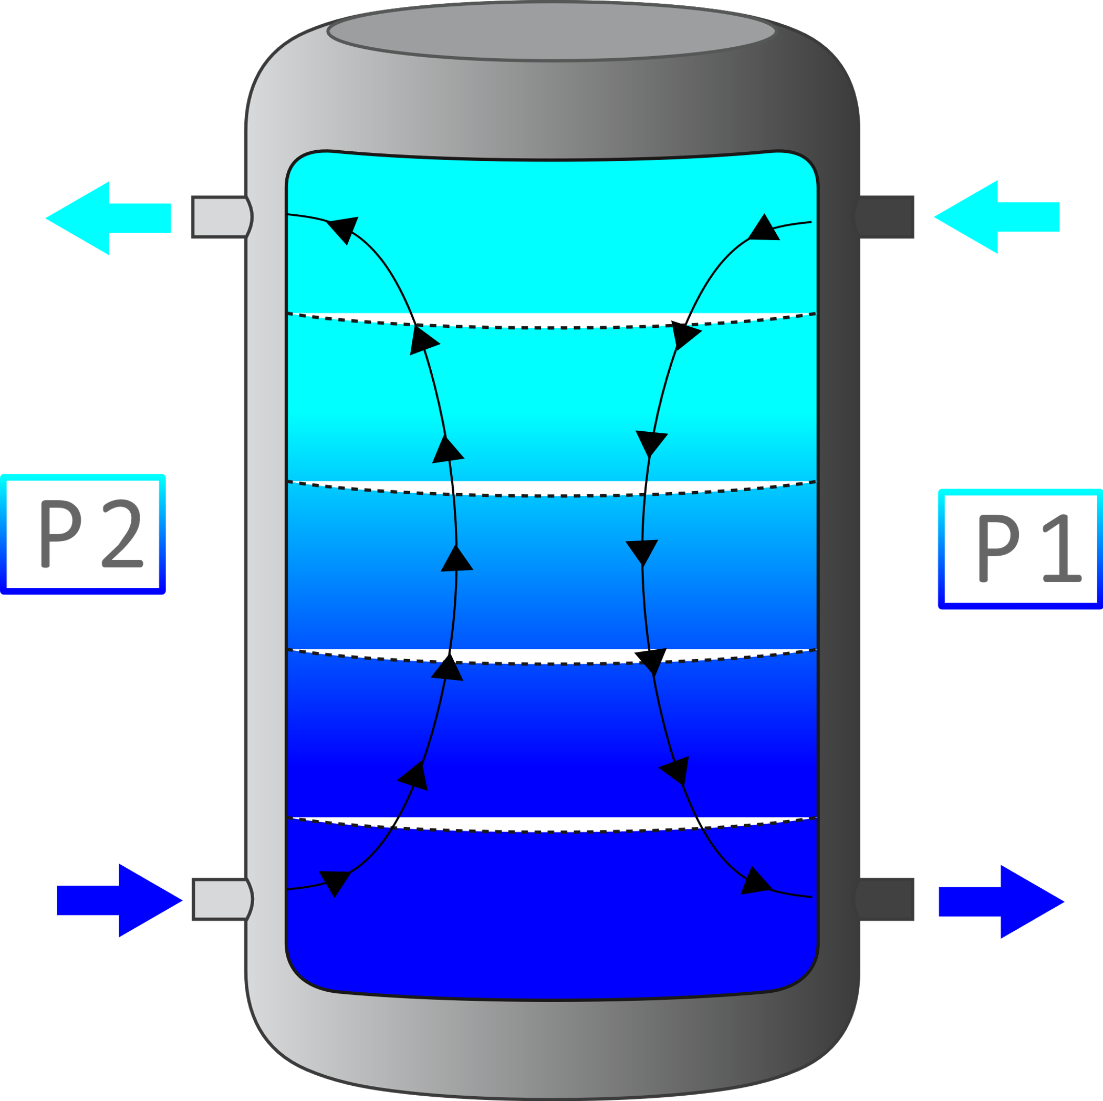

Figure 4 – Chilled water thermal storage system

The second loop (L2) corresponds to the hot water loop, whose hourly data of mass flow and temperature come from the Hot Water Production Macro, hourly data which in turn correspond to an input of the macro under analysis. The purpose of this hot water flow is to thermally feed the Generator integrated into the Advanced Absorption System. Once it has transferred its thermal energy, this flow leaves the Advanced Absorption Chiller at a lower temperature. The hourly data of this lower temperature water flow corresponds to an output of the macro under analysis, and at the same time, corresponds to an input of the Hot Water Production Macro. Within the macro under analysis, the only component considered corresponds to a hydraulic pump (PU02), as the piping is already considered within the External Macro.

The third loop, which corresponds to the cooling or rejection water loop, is formed by a cooling tower (CT01) and a pump (PU03). The cooling tower cools the fluid stream coming from the Advanced Absorption Machine using fans that can operate at low and high speed, and, in the case of being off, the cooling is produced by the natural convection phenomenon. This cooling water flow has the purpose of maintaining an optimum temperature inside the absorber and condenser inside the absorption chiller.

## Control scheme

Regarding the control, it operates with the following strategy:

Considering that the entire system is off AAC01 will come into operation when the following conditions are present together:

* + When the demand is greater than zero
  + When the hot water temperature is greater than or equal to 93 ° C
  + When the high temperature of the storage tank is greater than 13 ° C
  + If the above conditions are not met, AAC01 will remain off.

## Energy and mass balance

Heat balance are as by the following scheme:

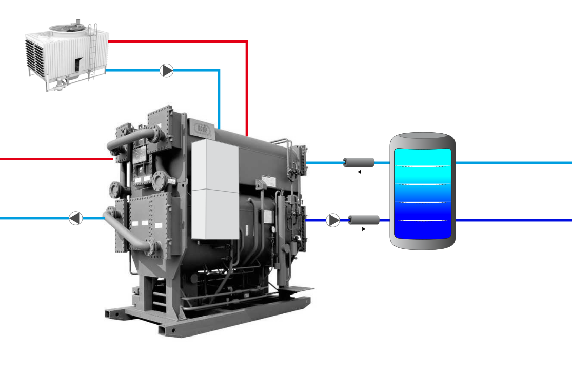

Heat and mass balance is shown in the following expression:

|  |  |
| --- | --- |
|  | Equation 4 |
|  | Equation 5 |
| % | Equation 6 |

# Validation Case

## Case

The case under analysis corresponds to a scenario in which the equipment is sized based on the design conditions stipulated in the project, which are mentioned below:

* M4100_AAC01_QCHWNom = 100 kW
* M4100_AAC01_COPNom = 0.8599
* M4100_AAC01_TCHWInNom = 12 °C
* M4100_AAC01_TCHWOuNom = 7 °C
* M4100_AAC01_THWInNom = 95 °C
* M4100_AAC01_THWOuNom = 90 °C
* M4100_AAC01_TCOWInNom = 31.5 °C
* M4100_AAC01_TCOWOuNom = 36.5 °C

Regarding the demand used, this is characterized by working with a constant mass flow, and whose value is the design value, i.e., 17,184 kg/hr. It should be noted that this value is obtained from the equations governing the conventional absorption system. As for the demand temperature, it has a staircase behavior that ranges from 8.66 to 12 °C.

Figure 5 – Demand temperature.

On the other hand, the temperature of the hot water entering the chiller is oscillating around 95°C. In this case study, this temperature is the main conditioning factor of the control system.

## Results

The following figure displays the results of the energy balance obtained from Equation 5. These values are in units of energy per time step (MW vs hr). As it is possible to appreciate from this figure, the results of the hourly energy balance have an oscillatory behavior, whose average is -1.5 MW.

Figure 5 – Hourly energy balance.

On an annual basis, the energy balance is -3%, a value attributed to the cyclical behavior of the system.